Idaho Falls American Legion Post 56
Receives Idaho Falls “Mayor’s Choice Award”

On February 13, 2022, Idaho Falls Mayor, Rebecca Casper, gave a State of the City address to the City Council and members of the public in attendance. Following her report, she gave out several Community Service Awards.
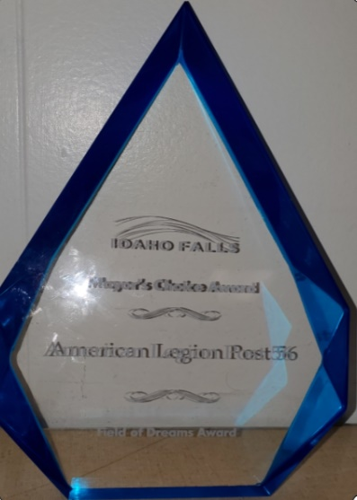
One of these “Mayor’s Choice Award” was given to American Legion Post 56. This coveted presentation was further inscribed as the “Field of Dreams” award reflecting the importance of baseball in the many communities and the people in those communities.
The American Legion award was presented for all the work done by the Post in support of the Bandits baseball team which has won the American Legion Baseball World Series two years in a row. They won in 2019 and 2021 (there was no world series in 2020 due to Covid).
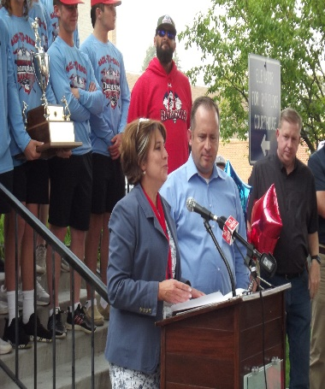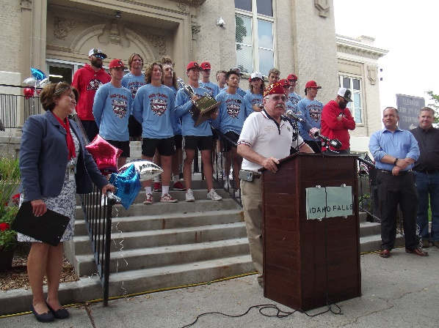
There were several events throughout the city celebrating the baseball team and their achievements. Post 56 of the American Legion in Idaho Falls is very active in Youth and Veterans programs.
This recognition was greatly appreciated.

